**TRAFFIC SIGNAL DESIGN USING ATMEGA32**

**REPORT:**

Traffic light control systems are widely used to monitor and control the flow of automobiles through the junction of many roads. Nowadays, many countries suffer from the traffic congestion problems that affect the transportation system in cities and cause serious dilemma. In spite of replacing traffic officers and flagmen by traffic systems, the optimization of the heavy traffic jam is still a major issue to be faced, especially with multiple junction nodes. The rapid increase of the number of automobiles and the constantly rising number of road users are not accompanied with promoted infrastructures with sufficient resources. Partial solutions were offered by constructing new roads, implementing flyovers and bypass roads, creating rings, and performing roads rehabilitation.

However, the traffic problem is very complicated due to the involvement of diverse parameters. First, the traffic flow depends on the time of the day where the traffic peak hours are generally in the morning and in the afternoon; on the days of the week where weekends reveal minimum load while Mondays and Fridays generally show dense traffic oriented from cities to their outskirts and in reverse direction respectively; and time of the year as holidays and summer

Traffic lights, developed since 1912, are signaling devices that are conceived to control the traffic flows at road intersections, pedestrian crossings, rail trains, and other locations. Traffic lights consist of three universal colored lights: the green light allows traffic to proceed in the indicated direction, the yellow light warns vehicles to prepare for shortstop, and the red signal prohibits any traffic from proceeding.

In our project Traffic signal design using ATMEGA32 “ATMEGA 32 “is the heart of TRAFFIC SIGNAL.

TRAFFIC lights are connected to B , D ports. This project contain 12 LEDS(4 Red,4 orange,4 green).

This is an Time based traffic control system.

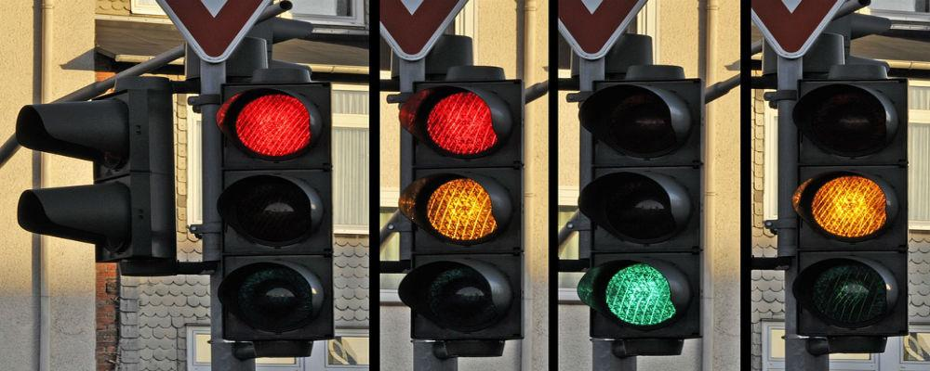

**COMPONENTS USED:**

* ATMEGA 32
* 4 Traffic signals
* Connecting wires

**ATMEGA 32:**

The AVR microController is based on the advanced Reduced Instruction Set Computer (RISC) architecture. ATmega32 microController is a low power CMOS technology based controller. Due to RISC architecture AVR microcontroller can execute 1 million of instructions per second if cycle frequency is 1 MHz provided by crystal oscillator.

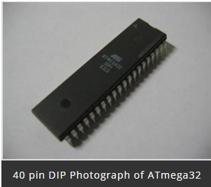

**Key Features:**

Consider some general features of ATmega32 microcontroller is:-

* 2 Kilo bytes of internal Static RAM
* 32 X 8 general working purpose registers
* 32 Kilo bytes of in system self programmable flash program memory.
* 1024 bytes EEPROM
* Programmable serial USART
* 8 Channel, 10 bit ADC
* One 16-bit timer/counter with separate prescaler, compare mode and capture mode.
* Available in 40 pin DIP, 44-pad QFN/MLF and 44-lead QTFP
* Two 8-bit timers/counters with separate prescalers and compare modes
* 32 programmable I/O lines
* In system programming by on-chip boot program
* Master/slave SPI serial interface
* 4 PWM channels
* Programmable watch dog timer with separate on-chip oscillator

**ATmega32 Microcontroller Pin Diagram**

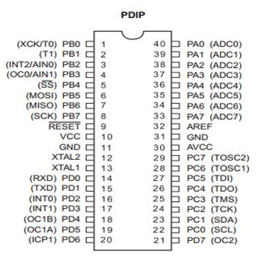

**TRAFFIC SIGNALS(LEDS)**

**LED**stands for **light emitting diode**. LED lighting products produce light up to 90% more efficiently than incandescent light bulbs. How do they work? An electrical current passes through a microchip, which illuminates the tiny light sources we call LEDs and the result is visible light. To prevent performance issues, the heat LEDs produce is absorbed into a heat sink.

### How are LEDs Used in Lighting

**LEDs** are incorporated into bulbs and fixtures for general lighting applications. Small in size, LEDs provide unique design opportunities. Some LED bulb solutions may physically resemble familiar light bulbs and better match the appearance of traditional light bulbs. Some LED light fixtures may have LEDs built in as a permanent light source. There are also hybrid approaches where a non-traditional “bulb” or replaceable light source format is used and specially designed for a unique fixture. LEDs offer a tremendous opportunity for innovation in lighting form factors and fit a wider breadth of applications than traditional lighting technologies.

**SOFTWARE USED:**

SimulIDE

SimulIDE is a simple real time electronic circuit simulator, intended for hobbyist or students to learn and experiment with simple electronic circuits and microcontrollers, supporting PIC, AVR and Arduino.  
  
This is not an accurate simulator for circuit analysis, it aims to be fast, simple and easy to use, this means simple and not very accurate electronic models and limited features.  
  
Simplicity and ease of use are the key features of this simulator.  
You can create, simulate and interact with your circuits within minutes, just drag components from the list, drop into the circuit, connect them and push power button to see how it works.  
  
SimulIDE also features a code Editor and Debugger for GcBasic, Arduino, PIC asm and AVR asm. It is still in it's firsts stages of development, with basic functionalities, but it is possible to write, compile and basic debugging with breakpoints, watch registers and global variables.



**TRAFFIC SIGNAL:**

A traffic signal, or stoplight as it is also known, controls vehicle traffic passing through the intersection of two or more roadways by giving a visual indication to drivers when to proceed, when to slow, and when to stop. In some cases, traffic signals also indicate to drivers when they may make a turn.

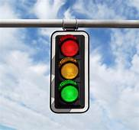

A traffic light controller circuit can be used for controlling the sequential illumination of the RED, ORANGE and GREEN traffic signal lamps, by maintaining appropriate delays between the illumination sequence.

In real traffic signal light system we all have seen how the red, orange and green lamps switch ON/OFF in sequence with specific amount of time delay between each lamps.

**How Traffic Signal Light Sequencing Works**

Basically, the traffic lights that we see on roads and highways illuminate with a specific sequence, as explained below:

* To indicate that the vehicles must STOP, the red traffic lamp is illuminated.
* Then after a relatively longish delay, the red lamp is shut off, and the green lamp is illuminated, which indicates that the vehicles must start the ignition and GO.
* Next, after a relatively longish delay the green light shuts off and the orange or the amber light is turned ON.
* The orange or the amber light tells the vehicles to PROCEED WITH CAUTION and prepare to stop to the red light that follows immediately, after a relatively short delay.

In this post we will try to build a realistic 3 color traffic light model, which will replicate the standard traffic light sequencing operation, as seen on roads and highways.

**Block diagram:**

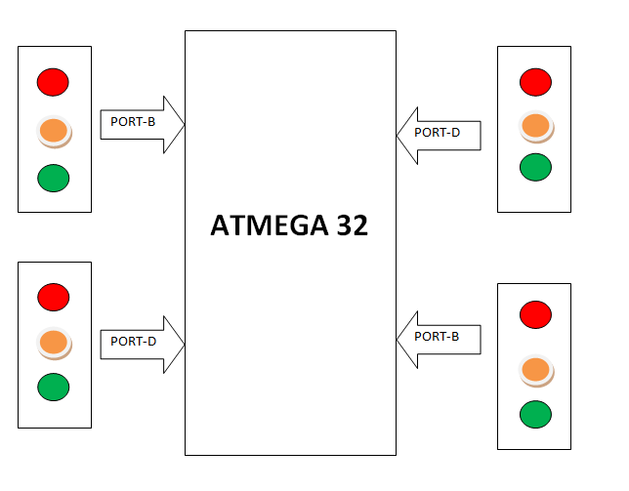

**Circuit diagram:**

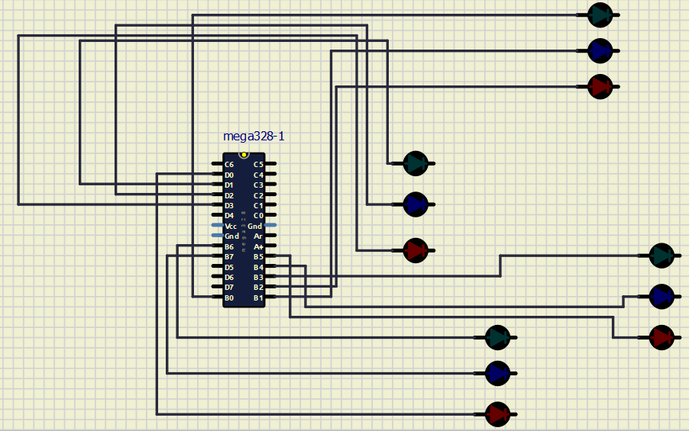

**CODE:**

**#include<avr/io.h>**

**#include<util/delay.h>**

**void main()**

**{**

**DDRB=0XFF;**

**DDRD=0XFF;**

**while(1)**

**{**

**PORTB=0b01001100;**

**PORTD=0b00000010;**

**_delay_ms(4000);**

**PORTB=0b01010010;**

**PORTD=0b00000010;**

**_delay_ms(1500);**

**PORTB=0b01100001;**

**PORTD=0b00000010;**

**_delay_ms(4000);**

**PORTB=0b10010001;**

**PORTD=0b00000010;**

**_delay_ms(1500);**

**PORTD=0b00000011;**

**PORTB=0b00001001;**

**_delay_ms(4000);**

**PORTB=0b10001001;**

**PORTD=0b00000100;**

**_delay_ms(1500);**

**PORTD=0b00001000;**

**PORTB=0b01001001;**

**_delay_ms(4000);**

**PORTD=0b00000100;**

**PORTB=0b01001010;**

**_delay_ms(1500);**

**}**

**}**

**Advantages of traffic signals :**

1. Traffic signals help for movement of traffic securely without any collision.

2. They can reduce the number of accidents on roads like pedestrian accident and right-angle collision of two cars.

3. Signals can increase the capacity of traffic handling at the intersection.

4. The traffic signals help for the safe movement of slow-moving traffic by interrupting heavy traffic at regular intervals.

5. The indications of the signals can be seen easily in foggy weather or at night time. Without signalling system, it is very difficult to control traffic by the traffic policeman at night or in foggy weather or on a rainy day.

**Disadvantages of Traffic Signals**:

1. They delay the traffic by stopping the vehicles at the intersection during peak hours.

2. During signals breakdown, there are serious and wide-spread traffic difficulties during peak hours.

**CONCLUSION**:

By using Traffic signals traffic jams may be decreased and accidents rate will be decreased.